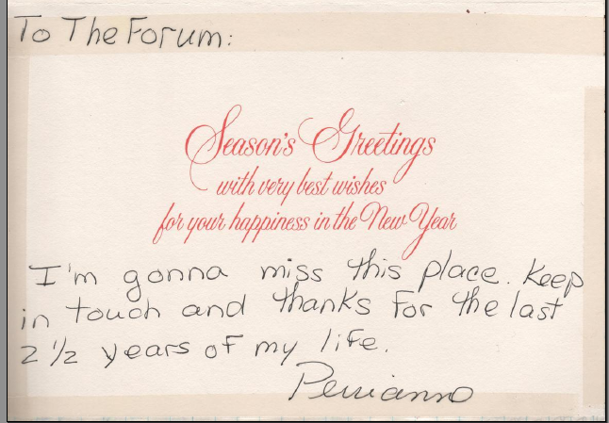
"I'm gonna miss this place. Keep in touch and thanks for the last 2½ years of my life"
Perrianne

(from Log 17, 1981-12-14)

