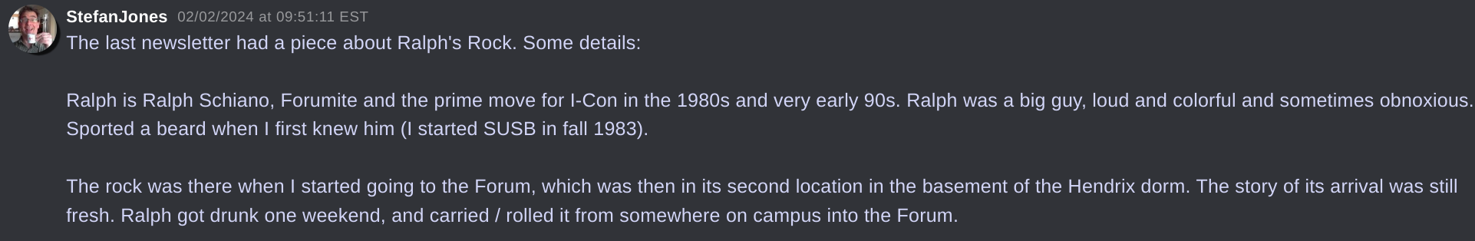
«StefanJones
02/02/2024 at 09:51:11 EST
The last newsletter had a piece about Ralph's Rock. Some details: Ralph is Ralph Schiano, Forumite and the prime move for I-Con in the 1980s and very early 90s. Ralph was a big guy, loud and colorful and sometimes obnoxious. Sported a beard when I first knew him (I started SUSB in fall 1983). The rock was there when I started going to the Forum, which was then in its second location in the basement of the Hendrix dorm. The story of its arrival was still fresh. Ralph got drunk one weekend, and carried / rolled it from somewhere on campus into the Forum.»
(Alumni Discord, #old-forumite-stories, 2024-02-02)

